
Company
Logotype

Cone Beam Computed Tomography- Report



Porur Dental X-rays & CBCT

Patient Name : Mr. LakshmiNarayanan | Date of Report : 06.07.2024
Age/ Gender : 75 years/ Male | Region of Interest : CBCT Mandible
Referring doctor: Dr. V. Sasikumar | Indication : Implant assessment
Clinical Notes: Nil
PATIENT INFORMATION

CBCT- Mandible provided
CBCT – IMAGE DETAILS

RADIOGRAPHIC INTERPRETATION

- Partially edentulous mandibular alveolar ridge.
- Root stumps in relation to 35, 36.
- The mandibular alveolar ridge is present with normal trabecular pattern.

IMPLANT ASSESSMENT

 | 31 region | 32 region | 33 region | 34 region
Sub-Crestal (in mm) | 3.76 | 4.16 | 4 | 5.04
Mid- Crestal (in mm) | 5.39 | 5.62 | 5.22 | 5.77
Distance between alveolar ridge and the inferior border of mandible (in mm) | 25.86 | 25.77 | 28.83 | 29.75
 | 41 region | 42 region | 43 region | 44 region
Sub-Crestal (in mm) | 2.58 | 2.58 | 5.32 | 5.46
Mid- Crestal (in mm) | 5.10 | 3.39 | 5.7 | 5.93
Distance between alveolar ridge and the inferior border of mandible (in mm) | 25.64 | 26.10 | 26.87 | 27.93

 | 35 region | 36 region | 37 region
Sub-Crestal (in mm) | 8.48 | 10.56 | 7.99
Mid- Crestal (in mm) | 8.87 | 11.03 | 9.72
Distance between alveolar ridge and the inferior alveolar nerve canal (in mm) | 10.55 | 9.01 | 15.97
Distance between alveolar ridge and the inferior border of mandible (in mm) | 25.06 | 20.88 | 27.82

 | 45 region | 46 region | 47 region
Sub-Crestal (in mm) | 5.18 | 5.77 | 10.19
Mid- Crestal (in mm) | 6.87 | 8.2 | 11.18
Distance between alveolar ridge and the inferior alveolar nerve canal (in mm) | 12.21 | 13.3 | 13.85
Distance between alveolar ridge and the inferior border of mandible (in mm) | 26.88 | 26.61 | 26.84

RADIOGRAPHIC IMPRESSION

- Partially edentulous mandibular alveolar ridge.
- Root stumps in relation to 35, 36.

Kindly correlate with clinical findings


IMAGES FOR REFERENCE

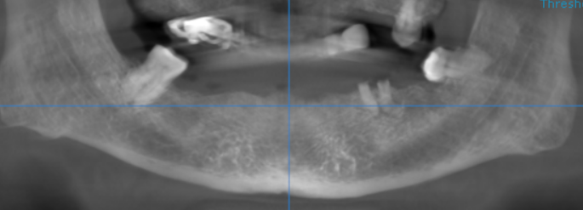
RECONSTRUCTED PANORAMIC VIEW

3-DIMENSIONAL VIEW

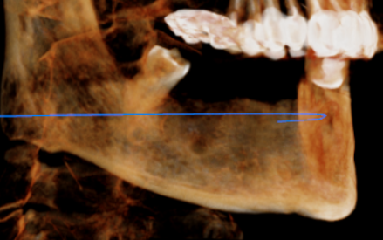
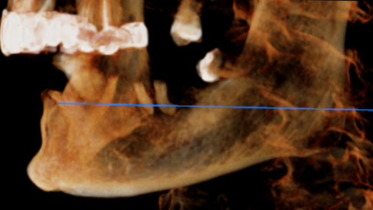

CROSS SECTIONAL VIEW

31 region | 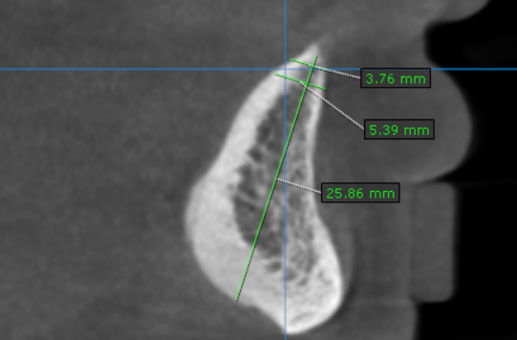
32 region | 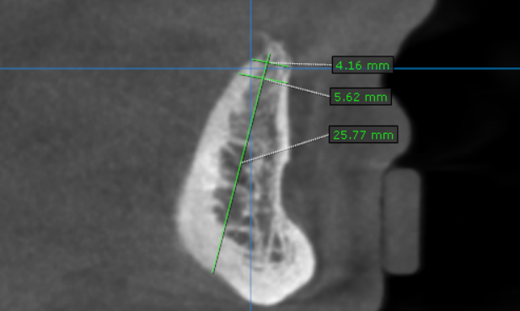
33 region | 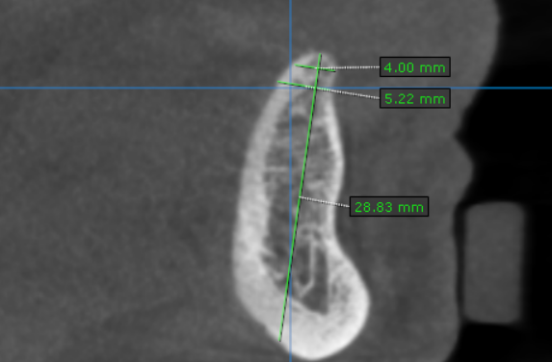
34 region | 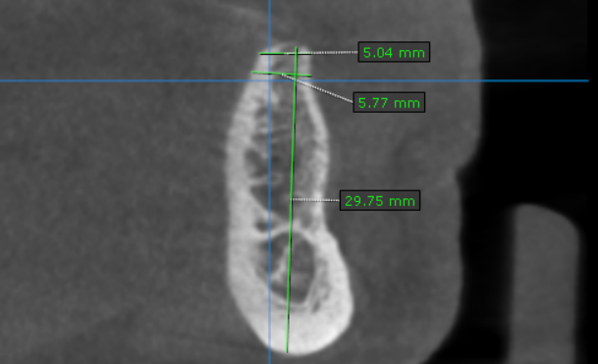
35 region | 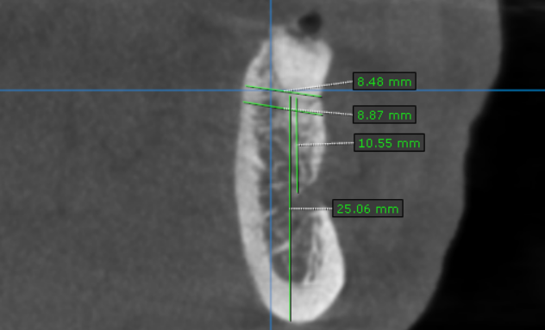
36 region | 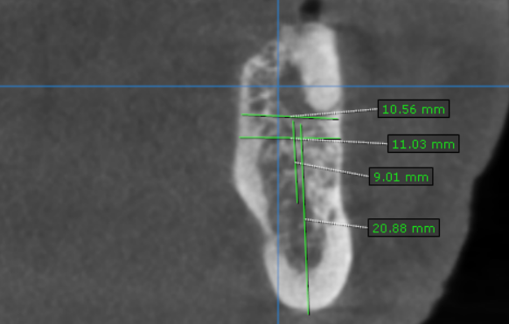
37 region | 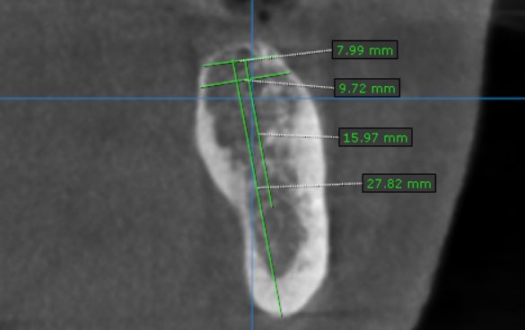
41 region | 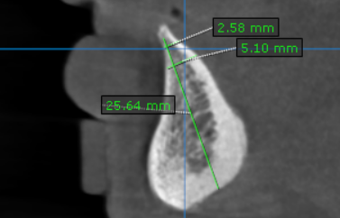
42 region | 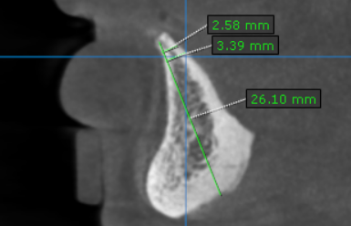
43 region | 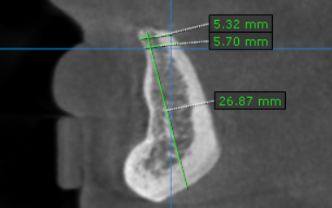
44 region | 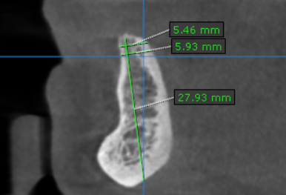
45 region | 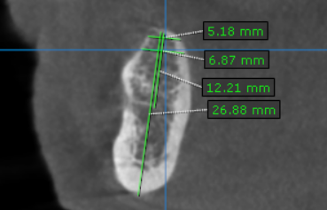
46 region | 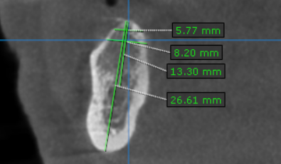
47 region | 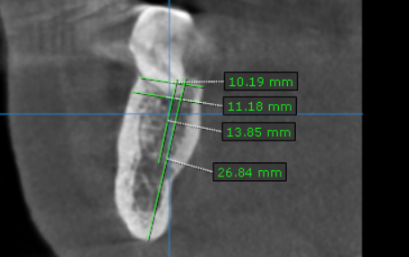

**** End of report ****

